**Canada Super Store Analysis using Power BI – Kaggle Project**

**Submitted by: Arvind Gongati**  
  
1. Order quantity by Province

a. Insight question: Which province shows you maximum orders and what is the ‘exact’ number of orders for this province?

Ans: The **Ontario** province has maximum orders among other provinces. The exact number of orders for the Ontario province is **27,840.**

2. Total Sales by Customer

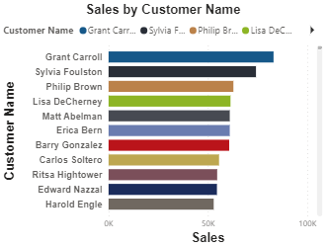

a. Insight question: Which customer had the maximum sales? Specify Name and exact sales amount?

Ans: **Grant Carroll** had the maximum sales as a customer. The sales amount is **82,990.33**.

3. Total Sales by Province using ‘Filled map’ (geographical representation)

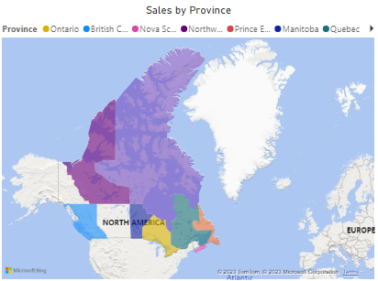

a. Insight question: Which province has the maximum sales and what is the exact amount of sales?

Ans: **Ontario** has the maximum sales compared to other provinces. The exact amount of sales is **17,48,758.22**.

4. Order Quantity Trend using ‘Area map’ (generally used for trends)

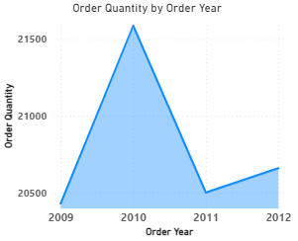

a. Insight question: Which year had the maximum order quantity and what was the exact number of orders?

Ans: The year **2010** had the maximum order quantity. The exact number of orders is **21,588**.

5. Your choice of another meaningful visualization and an insight.

Ans: The above visualization shows the sales of categories of products based on the Region.

**Insight:** The furniture sales amount of Quebec is 2,16,363.58 which is 29.5% greater than the amount obtained from Prairie, whose furniture sales amounted to 1,52,500.47.

6. Your choice of another meaningful visualization and an insight.

Ans: The above visualization presents the shipping charges incurred based on the categories of products.

**Insight:** More than 50% of the shipping costs are incurred from furniture-based orders.

7. Create Dashboard and paste a screen shot of the full dashboard (you can paste two screenshots if the full Dashboard does not fit in one ...but try to size the visualizations to fit on one screen. You can use this feature located on top menu bar of Dashboard to enter full screen mode and then take a screen shot of full Dashboard). Also try the ‘view insights’ feature (see screenshot under item 23 in tutorial) on Dashboard is very cool!

8. Open your dashboard and ‘Ask any question about your data’. Paste screen shots of any 3 questions you asked and their answers

